MODULE 4 – INTRODUCTION TO DBMS

LAB EXERCISES

3. SQL Constraint
Lab 1.
Add a CHECK constraint to ensure that the price of the books in the books table is greater than 0.
Ans.
1. ALTER TABLE books ADD CONSTRAINT chk_price CHECK (price > 0);
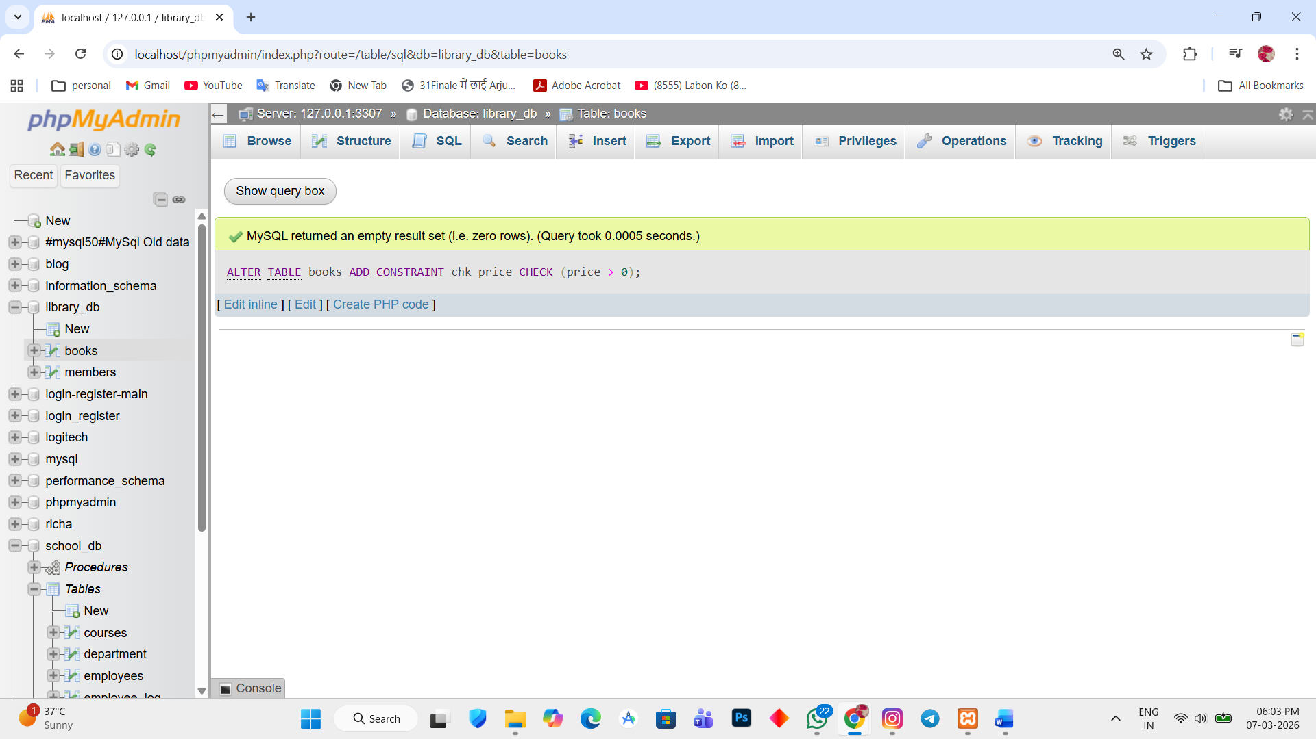

Lab 2.
Modify the members table to add a UNIQUE constraints on the email column, ensuring that each member has a unique email address.
Ans.
1. ALTER TABLE members ADD CONSTRAINT unique_email UNIQUE (email);
